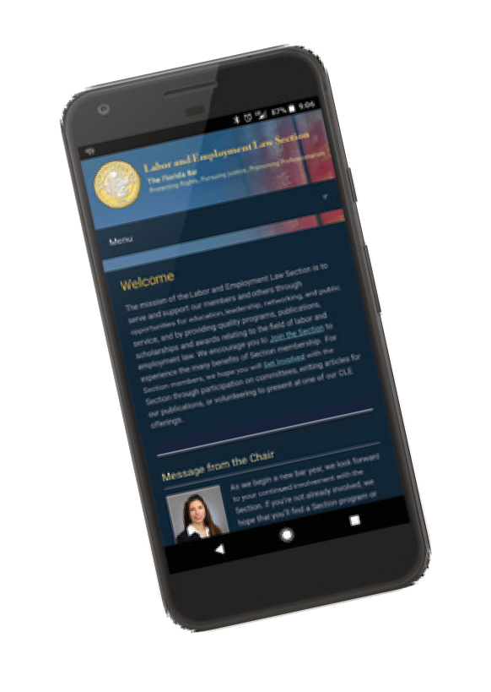
THE FLORIDA BAR
LABOR & EMPLOYMENT LAW SECTION
E - U P D A T E S
WWW .L ABOR E MPLOYMENT L AW . ORG
Carlo D. Marichal
March 2019
Publications Sub-Committee Chair
Register now for Advanced Labor Topics,
and make your hotel reservations by March 21.
See brochure on pages 2-3.

Circuit Split Remains After SCOTUS Vacates Equal Pay Act Decision Because of Judge’s Death
In Yovino v. Rizzo, an en banc opinion issued February 25th, the United States Supreme Court addressed whether a federal court may count the vote of a judge who dies before the decision is issued. SCOTUS initially considered reviewing Yovino—a Ninth Circuit opinion that held that salary history does not constitute a “factor other than sex” to justify a difference in pay under the Equal Pay Act—on the merits. The Court instead vacated Yovino because Judge Reinhardt, who wrote the majority opinion, passed away before the decision was published. Specifically, SCOTUS opined that only the votes of living judges count. The Ninth Circuit opinion was an en banc, 6-4 decision. If Judge Reinhardt’s vote did not count, there was not a true majority as it would have been a split, 5-5 decision. Furthermore, the Supreme Court noted that the five concurring judges on the Ninth Circuit agreed with the judgment but for different reasons. SCOTUS concluded: “Because Judge Reinhardt was no longer a judge at the time when the en banc decision in this case was filed, the Ninth Circuit erred in counting him as a member of the majority [F]ederal judges are appointed for life, not for eternity.”
While the Court did not address the merits of the appeal, it reminded practitioners of the circuit split on whether or not an employer can consider salary history as a “factor other than sex” to justify difference in pay under the Equal Pay Act. Judge McKeown’s concurring opinion in the Ninth Circuit’s decision succinctly set forth the circuit split. Judge McKeown noted that the Tenth and Eleventh Circuits hold that salary history alone cannot justify a pay differential, whereas the Eight Circuit allows the consideration of salary history but views the defense with scrutiny, and the Second Circuit allows the defense but requires the employer to also prove there is a bona fide business-related reason for the pay disparity. The Seventh Circuit, however, holds that salary history is always a “factor other than sex” to justify difference in pay. In light of the Court’s decision to vacate the Ninth Circuit’s opinion on a technicality, the circuit split remains.
There are other employment-related cases to watch in 2019. For example, the NLRB will likely take a stand on whether misclassifying workers as independent contractors unlawfully restricts their rights to organize and join unions under the National Labor Relations Act. Additionally, litigation against Facebook may ensue regarding whether or not the social networking company is an employment agency. The ACLU has filed charges of discrimination with the EEOC on behalf of women asserting that Facebook job ads were displayed only to male users. The ACLU is arguing that, if true, Facebook is an employment agency and subject to liability for discriminatory advertising.

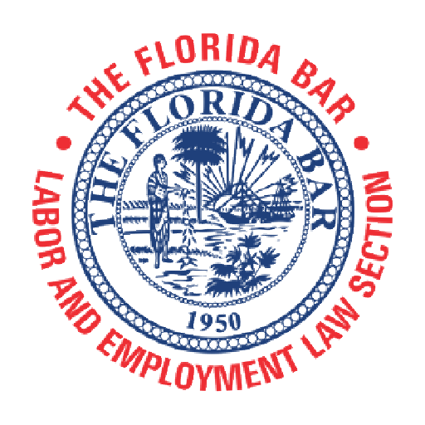Earn
9
hours of
CLE Credit!
1.0 Ethics

The Florida Bar Continuing Legal Education Committee and the Labor and Employment Law Section present

Advanced Labor Topics
2019
This advanced two-day seminar will review 11th Circuit EEO cases; discuss service animals in the workplace; provide wage and hour updates from inside the beltway; provide Supreme Court and agency updates; provide PERC and NLRB updates; present a view from the bench regarding professionalism in labor and employment law cases; and provide OSHA and HIPPA updates.

Course No. 2888R • Advanced Level
Live Presentation

Friday & Saturday, April 12-13, 2019
Wyndham Grand Jupiter at Harbourside Place
Certification Credit
Labor & Employment Law: 9 hours

122 Soundings Avenue
Jupiter, FL 33477

To register, log into The Florida Bar Members Portal at www.member.floridabar.org, click CLE Events/Meetings and scroll to the desired course.

Advanced Labor Topics 2019

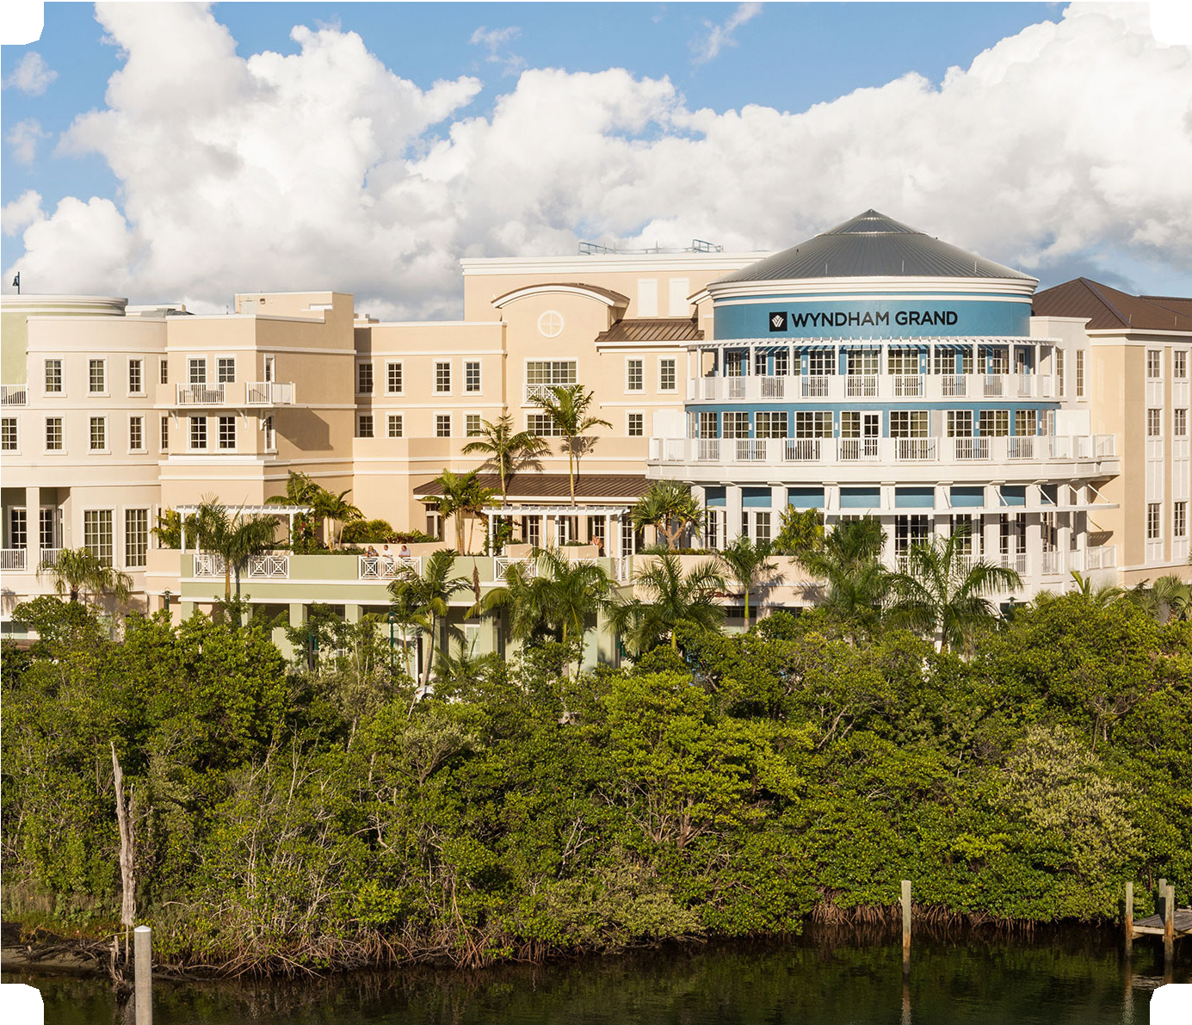Friday, April 12, 2019
12:00 noon – 12:25 p.m.
Late Registration
12:25 p.m. – 12:30 p.m.
Welcome and Introductory Remarks
Cynthia Sass, Sass Law Firm, Tampa – Program Co-Chair
Gregory A. Hearing, Thompson, Sizemore, Gonzalez & Hearing, P.A., Tampa – Program Co-Chair
12:30 p.m. – 1:45 p.m.
11th Circuit EEO Update
Robert E. Weisberg, Regional Attorney, Equal Employment Opportunity Commission, Miami
1:45 p.m. – 2:00 p.m.
Break
2:00 p.m. – 3:15 p.m.
Service Animals in the Workplace
Amanda Biondolino, Sass Law Firm, Tampa
Sacha Dyson, Thompson, Sizemore, Gonzalez & Hearing, P.A., Tampa
3:15 p.m. – 3:30 p.m.
Break
3:30 p.m. – 4:45 p.m.
Wage and Hour Update from Inside the Beltway
Keith Sonderling, Acting Administrator, U.S. Dept. of Labor, Wage and Hour Division, Washington, D.C.
5:00 p.m. – 6:00 p.m.
Labor and Employment Law Section Executive Council Meeting (all invited)

Wyndham Grand Jupiter at Harbourside Place
122 Soundings Avenue, Jupiter, FL 33477
A block of rooms has been reserved at the Wyn- dham Grand Jupiter at Harbourside Place at the rate of $215 single/double occupancy, which will be available until Thursday, March 21 at 5:00
p.m. est. or until the group block is sold out, whichever comes first. The group rate is available 3 days before and after the conference. The hotel services fee of $16 per room per day is waived for all guest rooms. Overnight self-parking is reduced to $8. Overnight valet parking is reduced to $16. To avoid a sold-out group block, please make your reservation as soon as possible by calling (855) 350-6809 or by clicking the link below. Identify yourself as a part of “The Florida Bar Advanced Labor Topics 2019” to receive the group rate.
Reservations:
561-273-6600
https://www.wyndhamhotels.com/groups/gr/the- fl-bar-advanced-labor-topics-2019
6:00 p.m. – 6:30 p.m.
Reception (included in registration fee)
6:30 p.m. – 8:30 p.m.
Dinner (included in registration fee)

Saturday, April 13, 2019
8:25 a.m. – 8:30 a.m.
Welcome and Introductory Remarks
Cynthia Sass, Sass Law Firm, Tampa – Program Co-Chair
Gregory A. Hearing, Thompson, Sizemore, Gonzalez & Hearing, P.A., Tampa
– Program Co-Chair
8:30 a.m. – 9:30 a.m.
Supreme Court and Agencies Update
Tammy McCutchen, Littler Mendelson, P.C., Washington, D.C.
9:30 a.m. – 10:30 a.m.
PERC & NLRB Update
Donald D. Slesnick, Law Offices of Slesnick & Casey LLP, Coral Gables Robert S. Turk, Stearns Weaver Miller Weissler Alhadeff & Sitterson, Miami
10:30 a.m. – 10:45 a.m.
Break
10:45 a.m. – 11:30 a.m.
A View From the Bench – Professionalism in Labor and Employ- ment Law Cases
The Honorable Anthony Porcelli, United States Magistrate Judge, Middle Dis- trict of Florida, Tampa Division
11:30 a.m. – 12:30 p.m.
OSHA & HIPPA Update
Eric Holshouser, Rogers Towers, P.A., Jacksonville

