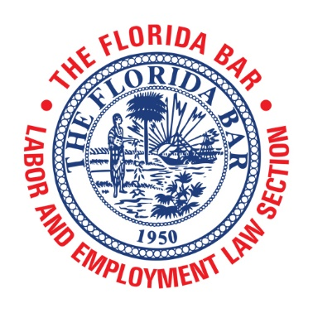
AGENDA

Labor and Employment Law Section Executive Council Meeting
Wyndham Grand Jupiter at Harbourside Place
122 Soundings Avenue, Jupiter, FL 33477
(561) 273-6600
(Ibis)

Friday, April 12, 2019
5:00 p.m. – 6:00 p.m.
Call-in Number: 1-888-376-5050
Participant Pin: 1563821345

I. Call to Order and Introductions – Cathleen Scott, Chair

Secretary/Treasurer Report – Alan O. Forst, Secretary/Treasurer

- Minutes – January 17, 2018 (Attachment A)
- February 2019 Financial Statement (Attachment B)

Committee and Subcommittee Reports

- Committees to Report on the Progress of their Goals (Attachment C)
- Bar Journal Committee Report – Robert Eschenfelder (Attachment D)

New Business

- Hall of Fame Nomination of Alan Gerlach (Attachment E)
- Hall of Fame Nomination of William Russell “Russ” Hamilton, III (Attachment F)
- Update on Gender Discrimination: The New Gender Equality Audio Webcast, June 5, 2019

Informational

Friday, April 12, 2019

12:25 a.m. – 4:45 p.m. Advanced Labor Topics 2019 (Dunes)
5:00 p.m. – 6:00 p.m. Labor Executive Council Meeting (Ibis)
6:00 p.m. – 6:30 p.m. Reception (Beacon)
6:30 p.m. – 8:30 p.m. Dinner (Beacon)

Saturday, April 13, 2019

8:25 a.m. – 12:30 p.m. Advanced Labor Topics 2019 (Dunes)

Next Executive Council Meeting
The Florida Bar Annual Convention 2019
Boca Raton Resort & Club
501 E. Camino Real, Boca Raton, FL 33432
(561) 447-3000

- Thursday, June 27, 2019

5:00 p.m. – 6:30 p.m.
Labor and Employment Law Section Executive Council Meeting

6:30 p.m. – 7:30 p.m.
Reception

- Friday, June 28, 2019

9:00 a.m. – 11:00 a.m.
Mediation and Arbitration Issues in Employment Matters: Thinking Outside the Box
Presented by the Alternative Dispute Resolution and Labor and Employment Law Sections

Adjournment

