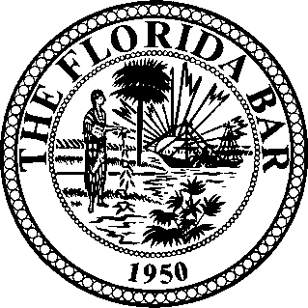
The Florida Bar • Labor and Employment Law Section
2018 - 2019 • COMMITTEE PREFERENCE FORM
Name: Attorney No. Address: City/State/Zip: Telephone ( ) Fax: ( ) Email Address:
Local/Voluntary Bar Assoc. Liaison Committee (LE639)
Long Range Planning Committee (LE623)
Membership Outreach Committee (LE641)
NLRB/PERC Liaison Committee (LE655)
Special Projects Committee (LE632)
Trial Skills Seminar Committee (LE656) NEW
Wage & Hour Administration Liaison Committee (LE660)
Workplace Health & Safety Committee (LE680)
Communications Committee (LE644):
Publications Subcommittee (Checkoff/Journal) (LE622)
Social Media/Advertising Subcommittee (LE642)
Website Subcommittee (LE635)
ABA Liaison Committee (LE640)
Bar Leadership Liaison Committee (LE665)
Corporate Counsel Committee (LE670)
EEOC/FEPA Liaison Committee (LE650)
Immigration Committee (LE675)
Judicial Outreach Committee (LE645)
Law School Liaison Committee (LE638)
I am interested in serving on the:

If applicable, describe your contributions to Section CLE programs, publications and Committee activities:

Area of Practice: Please complete and return ASAP to:
Government Angie Froelich
Management The Florida Bar
Plaintiff 651 East Jefferson Street
Union Tallahassee, Florida 32399-2300
Other Fax: (850)561-9427 or afroelich@flabar.org

Please E-Mail, Fax Or Mail this Form.

