Charles (Charlie) H. Kossuth, Jr.
(1938-2011)
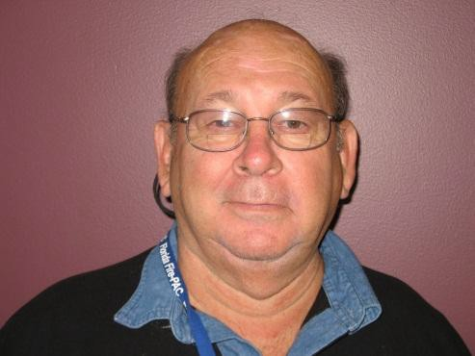
Inaugural Inductee into the Labor and Employment Law Section Hall of Fame June 2012

Charles (Charlie) H. Kossuth, Jr., was a legendary figure in public sector labor relations throughout the United States, Canada, and the United States Virgin Islands, in which he was known as a fearless and ardent proponent of fire fighter unionization. After service in the United States Air Force, where he played baseball, Charlie began as a fire fighter in Dade County in 1959. He became the union president two years later and negotiated one of the first public employee collective bargaining agreements in Florida.

Charlie attended the Trade Union Program at Harvard University Graduate School on an International Association of Firefighters (IAFF) scholarship and in 1970 became a Staff Representative with that organization in Washington, D.C. In this capacity he assisted fire fighter local unions in labor relations, including negotiations, grievances, mediations, arbitrations, strikes, lobbying, education, and organizing. He had a reputation of being intelligent and tough, but fair and reasonable.

Charlie retired from the IAFF in 1991, and was elected Vice President of the Florida Professional Fire Fighters, which included lobbying the Florida Legislature and Cabinet, and United States Congress, and he assisted over 150 locals throughout the State. He was appointed by Governor Jeb Bush as a Commissioner of the Florida Public Employees Relations Commission (PERC) in January 2001 and served two terms totaling eight years. As a PERC Commissioner he was a quasi judicial officer deciding thousands of significant public sector labor and employment cases. He demonstrated outstanding scholarship in labor relations law. He was very popular with the PERC staff because he was kind, humble, generous, and gregarious.

Even after leaving PERC, he kept in daily contact with PERC staff and rendered invaluable assistance to its legislative efforts. Charlie also made numerous presentations to such organizations as the Labor and Employment Section of the Florida Bar and annual meetings of the Florida Professional Fire Fighters, which established a yearly attorneys' luncheon in his name. He is cited by attorney W. Jeffrey Carnes in his book "A Survivor's Guide to a Successful Public Sector Union" as being the first and most significant influence on his pursuit of labor law. Fittingly, Charlie passed away at the Florida Professional Fire Fighter annual conference in Jacksonville, which held an impromptu service in his recognition. The 2012 conference will be dedicated to him.

