Irving Miller
(1940-2003)

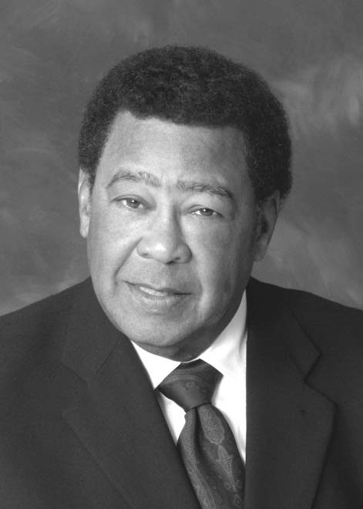
Inaugural Inductee into the Labor and Employment Law Section Hall of Fame June 2012

Irving M. Miller practiced in the areas of employment and labor law, wage and hour and ERISA litigation. Admitted to practice in Florida, Iowa, Illinois, Michigan and Colorado, he was a member of the American and National bar associations, the American Society for Personnel Administration, the Florida Bankers Association, the Personnel Association of Greater Miami, the Greater Miami Chamber of Commerce Human Resources Committee, the Conference of Minority Partners in Majority/Corporate Law Firms and was an emeritus member of the Florida Board of Bar Examiners. Irv was also active in the Black Lawyers Association of Dade County and served as vice president in 1989 and 1990. He graduated from the University of Iowa School of Law and Parsons College.

Although Irv has a distinguished career before settling in Florida, he was best known in Florida for his service as Regional Attorney for the Equal Employment Opportunity Commission’s Miami district office. Irv also worked with Akerman Senterfitt in Miami for 18 years before changing to the Duane Morris firm shortly before he passed away.

Irv also wrote and lectured extensively on employment law matters. He was a lecturer for the University of Miami School of Law, the Golden Gate University School of Law and an adjunct associate professor of law for the Wayne State University of Law in Detroit. He was a faculty member for the American Banking Association's Graduate School of Banking and the Louisiana State University Graduate School of Banking of the South.

