William E. Sizemore
(1945-2004)
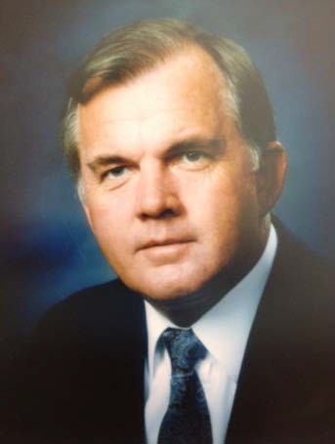
Inaugural Inductee into the Labor and Employment Law Section Hall of Fame June 2012

William E. Sizemore was born in Ormand Beach, Florida graduated from Florida State University (to him, THE university of Florida) in 1966. He attended Stetson University’s College of Law, from which he received his juris doctorate degree in 1969. Bill was admitted to The Florida Bar in the same year, after receiving the highest score in the state on the Bar examination. In 1970, he joined the firm of Shackleford, Farrior, Stallings & Evans, where he began practicing management-side labor law and formed many enduring friendships. While in that role, Bill served as Chair of what was then the Labor Law Committee of The Florida Bar in 1975/76. Bill became a partner in that firm and later served as its president.

In 1983, wanting his own firm, Bill left Shackleford, Farrior, Stallings & Evans to co-found the firm of Thompson, Sizemore & Gonzalez, n/k/a Thompson, Sizemore, Gonzalez & Hearing, P.A., where he practiced for the remainder of his life. The hallmarks of Bill’s practice were his intellect and his ability, but above all, his passion for and dedication to his clients. His efforts were rewarded by the opportunity to represent clients in virtually every sector of industry and government. His knowledge and skill in the area of traditional labor relations were second to none.

Bill was also recognized by his fellow lawyers, who elected him to the Board and presidency of the Hillsborough County Bar Association as well as the Young Lawyers Board and the Board of Governors of The Florida Bar. He was recognized by the publication Best Lawyers in America in the 1987 edition and in every edition thereafter. He also served as an adjunct professor of labor law at Stetson University. But above all of this, he treasured the confidence and loyalty of his clients. Bill was a great partner, a wonderful mentor and a superb lawyer. He left his partners, associates and other co-workers with a profound sense of loss and deep appreciation for his heart, his loyalty, and his compassion. Bill’s contributions to the field of labor and employment law were great, and all who practiced with him and even those he litigated against would agree that his skill and professionalism were of the highest caliber.

