Harrison C. “Tommy” Thompson, Jr.
(1925-1994)
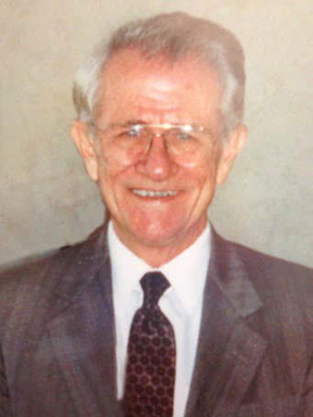
Inaugural Inductee into the Labor and Employment Law Section Hall of Fame June 2012

Harrison C. “Tommy” Thompson, Jr. was one of the preeminent labor lawyers in America. Following combat service with Patton’s Third Army, a war-interrupted stint with the Daytona Beach Life Guard Corps and graduation from Stetson University College of Law, Tommy went to work for the National Labor Relations Board as a Trial and later Supervising Attorney for the Fort Worth, New Orleans and Atlanta regional offices before becoming part of the first staff for the Tampa office of Region 12.

In 1960, Tommy left the government to join Shackelford, Farrior, Stallings & Evans as a partner and began the firm’s labor law section. In 1983, he left Shackleford, Farrior, Stallings & Evans to co-found the firm of Thompson, Sizemore & Gonzalez, n/k/a Thompson, Sizemore, Gonzalez & Hearing, P.A., where he practiced for the remainder of his life.

Tommy was among Florida’s first labor lawyers, and took part in many major union campaigns throughout the southeast and southwest, involving virtually every industry and involving companies as varied as Jim Walter, Jack Eckerd, Schlitz Breweries, the Daytona News-Journal, Frito-Lay and Keller Industries. He took part in many important Board cases, most famously Better Monkey Grip, and a host of union negotiations, arbitrations, and wage and hour matters. He is best remembered for his tenacity and dogged determination in the defense of labor cases. He was recognized by the publication Best Lawyers in America. He was also active in what then was referred to as the Labor Law Committee for The Florida Bar.

Tommy was a great lawyer and a wonderful mentor to those he developed in the practice of law over his career. A true Southern gentleman, Tommy was well-regarded by all who encountered him.

