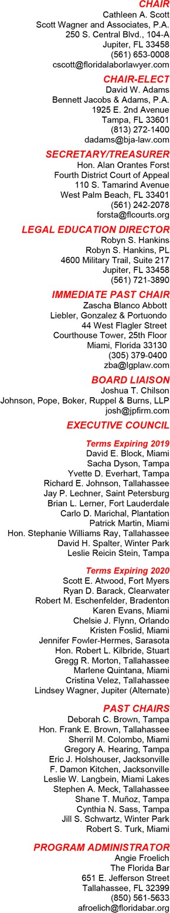

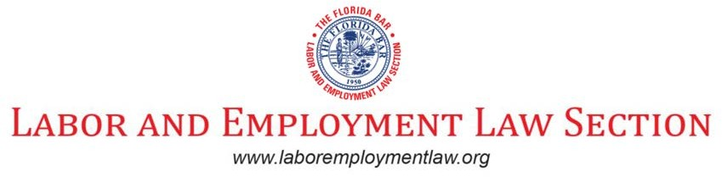

January 16, 2019

Re: Agenda – January 17, 2019 at 5:00 p.m. e.s.t.

Dear Labor and Employment Law Section Executive Council Members and Committee Chairs,

The Labor & Employment Law Section executive council meeting will take place on Thursday, January 17, 2019, at 5:00 p.m. e.s.t. at the Doubletree by Hilton Orlando at SeaWorld, 10100 International Drive, Orlando, FL 32821, (407) 352-1100.

The Wi-Fi Passcode at Winter Meeting is flabar.

The agenda and supporting documents for this meeting are attached.

For those who cannot attend in person, conference call information is listed below.

Toll-free number: 888-376-5050
Conference Code: 1563821345

HOTEL ROOM ASSIGNMENTS

Thursday, January 17, 2019

8:10 a.m. – 4:45 p.m. 19th LE Update & Cert Review (Majestic 1) 11:40 a.m. – 12:40 p.m. 2882 Lunch (Majestic 2)
5:00 p.m. – 6:00 p.m. Labor EC Meeting (Harbor A) 6:00 p.m. – 7:00 p.m. Reception (Majestic 2)
7:00 p.m. – 8:30 p.m. Dessert Reception in Chair’s Suite

Friday, January 18, 2019

8:00 a.m. – 4:30 p.m. 19th LE Update & Cert Review (Majestic 1) 12:05 p.m. – 1:35 p.m. 2882 Lunch (Majestic 2)

I look forward to seeing you in Orlando. Angie

THE FLORIDA BAR • 651 E. JEFFERSON STREET • TALLAHASSEE, FLORIDA 32399-2300

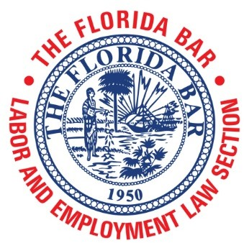
AGENDA

Labor and Employment Law Section Executive Council Meeting Doubletree by Hilton Orlando at SeaWorld
10100 International Drive, Orlando, FL 32821
Harbor A

Thursday, January 17, 2019
5:00 p.m. – 6:00 p.m.
Call-in Number: 1-888-376-5050
Participant Pin: 1563821345

WI-FI Passcode: flabar

- Call to Order and Introductions – Cathleen Scott, Chair

- Secretary/Treasurer Report – Alan O. Forst, Secretary/Treasurer

  - Minutes – October 25, 2018 (Attachment A)
  - November 2018 Financial Statement (Attachment B)

Committee and Subcommittee Reports

  - Committees to Report on the Progress of their Goals (Attachment C)
  - Bar Journal Committee Report – Robert Eschenfelder (Attachment D)
  - Special Committee on Certification Review Seminar (Attachment E)

New Business

  - Leadership Meeting at Wyndham Grand Jupiter at Harbourside Place
  - Hall of Fame Nomination of Margie Cooper of Jones Foster (Attachment F)
  - Section Bulletin Board (Attachment G)

  - Updated - 19th Labor and Employment Annual Update and Certification Review Brochure (Attachment H)
  - Updated - 2018-2019 Labor Audio Webcast Brochure (Attachment I)
  - Reception in Chair’s Suite – Suite No. & Directions (Attachment J)
  - Winter Meeting 2019 Map (Attachment K)

Informational Thursday, January 17, 2019
8:10 a.m. – 4:45 p.m. 19th Update and Certification Review (Majestic 1)
11:40 a.m. – 12:40 p.m. 2882 Lunch (Majestic 2)
5:00 p.m. – 6:00 p.m. Labor EC Meeting (Harbor A) 6:00 p.m. – 7:00 p.m. Reception (Majestic 2)
7:00 p.m. – 8:30 p.m. Dessert Reception in Chair’s Suite

Friday, January 18, 2019

8:00 a.m. – 4:30 p.m. 19th Update and Certification Review (Majestic 1) 12:05 a.m. – 1:35 p.m. 2882 Lunch (Majestic 2)

Next Executive Council / Leadership Meeting

  - Saturday, April 13, 2019
Wyndham Grand Jupiter at Harbourside Place 122 Soundings Avenue, Jupiter, FL 33477
(561) 273-6600

Adjournment

MINUTES

October 25, 2018 Executive Council Meeting Labor and Employment Law Section, The Florida Bar Rosen Shingle Creek, Orlando, FL

Cathleen Scott, Chair David Adams, Chair-Elect
Robyn Hankins, Legal Education Director* Hon. Alan Forst, Secretary-Treasurer Zascha B. Abbott, Immediate Past Chair* Angie Froelich, Section Administrator Joshua Chilson, Board Liaison*
David Block* Deborah Brown

Hon. Frank Brown Sherril Colombo* Robert Eschenfelder Yvette Everhart*
Jennifer Fowler-Hermes* Eric Holshouser*
Hon. Robert Kilbride*
F. Damon Kitchen Leslie Langbein Jay Lechner Brian Lerner* Carlo Marichal* Gregg Morton
Hon. Stephanie Ray* Cynthia Sass*
Jill Schwartz* David Spalter* Leslie Reicin Stein* Robert Turk* Cristina Velez* Lindsey Wagner*

*Appearing by phone

Call to Order
Guests

James Poindexter Will Rothenberg Tom Young Danielle Martin

President Cathleen Scott called the meeting to order at 5:07 p.m. A quorum of the Executive Council was present either in person or by telephone. The meeting began with Cathleen thanking Brian Lerner for his work in securing a new conference call system for EC meetings (in light of the problems we had with the phones at that meeting, this appreciation might be akin to “Mrs.

Kennedy and I appreciate the suggestion that we put the top down for the motorcade.”). Cathleen next requested the approval of the minutes (Agenda Attachment A) from the September 13, 2018 meeting. Leslie Langbein requested that the minutes be amended to show she had an excused absence. With that amendment, the proposed minutes were approved (Eschenfelder moving, Brown seconding).

Secretary/Treasurer Report

Judge Forst referenced the proposed budget for 2019-20 (Agenda Attachment
B) that was an agenda attachment. In an eloquent presentation which had the room spellbound, Judge Forst detailed the interesting budgetary trends (ok, I’m kidding about the eloquent and spellbound and my notes don’t even reflect what I said because I can’t write and speak at the same time). Judge Forst noted that we had room (lots of room) to improve upon our revenue produced from webcasts, sponsorships, CD/DVD/VCR/Laser Disc sales, advertising and investment allocation. RAAC Chairman Brown inquired about the decline in CLE revenue and Administrator Froelich responded that CLE revenue is down throughout the Bar. Discussion (led by Brian Lerner) then turned to the development of the Section’s website, with the expectation that we will be paying more for the website in 2019-20 (more discussion later in the meeting). Rob Eschenfelder (“RobE”) moved, David Adams seconded the approval of the budget. Approval was unanimous.

Committee Reports

Odds and Ends: Several of the Committees/Subcommittees submitted written reports (Agenda Attachments C & D). The ABA Liaison Subcommittee made note of a then-upcoming Trial Advocacy law student competition. The Judicial Outreach Subcommittee announced that Section Chair Scott would be joining Judges Forst and Sasser to present an employment law course for judges at the Florida Judiciary’s Advanced Judicial Studies program in May 2019. Cristina Velez noted that the Law School Liaison Subcommittee was in the process of shuffling school assignments for the scholarship review and would be updating its committee goals. Bob Turk called attention to the Georgia Bar Labor Section’s mentoring project and Bob noted that we would follow up with the chair of that effort. Eric Holshouser requested that OSHA be included in the Advanced Labor Topics Seminar. RobE suggested that the Section award a Bar Journal article of the year at the annual convention. Chair Scott, in soliciting Checkoff articles, suggested that we use webinar materials (after the webinar).

Long Range Planning: Judge Kilbride stated that the Long Range Planning Committee had met and they were working on action items from the April retreat. He noted that the Administrative Law Section was, similarly to our Section, looking into hosting a trial academy. He also noted that some work on the

Section’s new phone system was necessary (we think that’s what he said—he was appearing by phone). He also announced that the Section archiving project was underway, led by RobE.

The aforementioned RobE reported that, as part of the archiving project, he’s looking at Section EC votes of historical significance. He observed there were votes to create a listserve, followed by votes to kill the listserve, and arguments made to spend more and have more retreats. He noted the absence of minutes with respect to “one-off” decisions and retreats. He also recounted the Cynthia Sass Rosen Centre/Rosen Plaza adventure narrative which was discovered in the Section minutes. Finally, he suggested that the Section’s Secretary/Treasurer be responsible in the future for updating the Archives.

Special Projects: RAAC Chairman Brown thanked RobE for undertaking the archiving project. He then pivoted to discussion of the Section’s Annual Certification Review and Update Seminar, which included his Memorandum reporting on an October 18, 2018 teleconference of the Ad Hoc Committee on Update/Certification Review Seminar (Agenda Attachment E). Chairman Brown expressed an interest in the course providing information necessary for individuals preparing to take the Certification Exam. Leslie Langbein enquired as to how many people sit for the Exam. Robyn Hankins answered about 9-14 per year and suggested that a mentoring program might be appropriate. RobE noted there has been a lot of discussion regarding the purpose of this seminar, and we shouldn’t overplay the focus on the exam takers or underplay the focus on individuals seeing an extensive review course. Robyn expressed her belief that it was important to consult with one of the Certification Committee members and do a better job of marketing this seminar. Chair Scott thanked the committee and suggested that the Update/Certification Review co-chairs take the lead on implementing the Ad hoc Committee’s proposals.

Wage & Hour Subcommittee: Robyn provided the Subcommittee report. She noted that the FLSA analysis project is evolving and help is needed on this project. Leslie Langbein offered to co-chair the subcommittee with Jay Lechner and Leslie noted that the Florida Bar has surveyed judges regarding their practices and procedures and that the survey is inaccurate and out of date. Robyn responded that the subcommittee has more up-to-date information and the subcommittee will continue to update. Chair Scott suggested that section members receive this information by email.

Website Subcommittee: Brian Lerner reported that he initiated a conference call of the subcommittee to answer any questions the Executive Council may have regarding vendor proposals to update and administer the Section’s website. Proposals ranged from $3000 to $20000. At the high end was a vendor associated with The Florida Bar. Our current vendor made a bid of $6500 which Brian characterized as in the mid-low range of bids. Brian stated that Elyk provides good options and that their service had been good. He suggested that

the Executive Council move forward with Elyk and that he work on a final contract for consideration. He also noted that the Section budget reflects $1500 dedicated to the website, which would require an increase in light of this special project. In response to Judge Kilbride’s question, Brian noted that Elyk would update the design of our website (which is still using 2011-12 design). In response to a Kilbride/Adams motion, the Section voted to approve Elyk as the vendor to design the Section’s new website, with a budget of “up to” $8500 per year to update and administer the website.

New Business

Chair Scott referenced the Survey Results (Agenda Attachment F) with respect to the need for and structure of “a multi-day, intensive trial seminar hosted by the Labor and Employment Law Section.” Chair Scott and Leslie Langbein felt that the survey reflected a desire for a seminar similar to the old Stetson trial seminar. RAAC Chairman Brown stated that we need to first find a sponsor for the program, preferably a law school. Chair Scott responded that there is an ad hoc committee working on this. Jay Lechner noted that people don’t want to pay out-of-pocket for this seminar. Chair Scott stated that there would be more discussion of this proposed seminar in the future.

Chair Scott declared that she was very happy with the 2018-19 Audio Webcast Series (Agenda Attachment H), with outstanding presentations/faculty lined up. The webinars were available as a buy 6, get one free.

The Chair invited members and guests to attend a Section reception following the meeting, as well as a dessert reception in her suite following the regular reception.

Adjournment

Leslie/RobE moved to adjourn. The meeting was adjourned at 6:05 p.m.

Next Executive Council Meeting

The next Executive Council Meeting will take place at 5:00 p.m. on Thursday, January 17, 2019 at the DoubleTree by Hilton Orlando at Sea World.

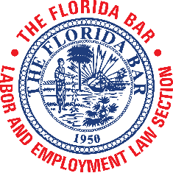

Labor & Employment Law Section

2018 – 2019
FINANCIAL STATEMENT

SECTION – November 30, 2018

Beginning Fiscal Year Fund Balance $99,944

Total Revenue $103,704
Total Expenses ($52,583)

Net Operations $51,121

Ending Fiscal Year Fund Balance $151,065*
*see attached statement of operations

CURRENT MEMBERSHIP

Current Membership 2,042

THE FLORIDA BAR
Labor and Employment Law Section
For the Month Ending November 30, 2018
Total Revenue | 103,704 | 159,307

2019 | 2019
Description Actual | Budget
3001-Annual Fees (member dues) $90,400 | $90,090
3002-Affiliate Fees (affiliate dues) 800 | 1,020
Total Fee Revenue 91,200 | 91,110
3321-Registration-Webcast (section InReach revenue) (zero'd out)
Total Registration Revenue

900
900

3351-Sponsorships (sponsor or exhibitor revenue) | 2,500
3391 Section Profit Split (Joint CLE 80-20 split with CLE Committee) | 11,538 | 49,000
3392-Section Differential (Joint CLE - Difference in member/non-member fees) | 1,718 | 5,200
Other Event Revenue | 15,756 | 54,200
3561-Advertising (advertising in Checkoff/website)
Advertising & Subscription Revenue

0 | 1,900
0 | 1,900

3899-Investment Allocation (Bar's investment of section funds) | (3,252) | 11,197
Non-Operating Income | (3,252) | 11,197

4131-Telephone Expense (business phone - split among 3 sections) |  | 800
4133-Internet Service (section wifi - split among 3 sections) |  | 550
4134-Web Services (website) | 1,760 | 8,500
4301-Photocopying (copying) (zero'd out) |  | 165
4311-Office Supplies (supplies, e.g. name badge holders) | 78 | 400
Total Staff & Office Expense | 1,838 | 10,415

5051-Credit Card Fees (.02% for all fees. Actual fees since fy 17-18) | 351 | 600
5121-Printing-Outside (printing newsletter outside Bar / Paid Editor) | 950 | 4,000
Total Contract Services | 1,301 | 4,600

5501-Employee Travel (staff travel per formula) | 862 | 8,255
5531-Board/Off/Memb Travel (officer travel / out-of-state travel) |  | 1,250
5599-Other Travel (meeting travel expense) | 6,647 | 22,500
Total Travel | 7,509 | 32,005

6001-Post 1st Class/Bulk (mailing) | 46 | 500
6301-Mtgs TFB Annual Meeting (annual convention) | 292 | 13,000
6311-Mtgs General Meeting (council mtgs / winter meeting) | 616 | 5,600
6319-Mtgs Other Functions (Section retreat / section service program) |  | 5,000
6321-Mtgs Meals (section dinners) |  | 10,000
6325-Mtgs Hospitality (section receptions) | 4,455 | 10,500

 | 2019 | 2019
Description | Actual | Budget
6399-Mtgs Other (long range planning retreat) |  | 5,000
6401-Speaker Expense (speaker exp not covered by CLE Committee) |  | 5,000
6451-Committee Expense (LE cmte / cert cmte) |  | 2,000
6599-Brd/Off Other (chair's annual convention expenses) |  | 400
7001-Grant/Award/Donation (awards) | 55 | 7,000
7011-Scholarship/Fellowship (law school scholarships) |  | 12,000
7999-Other Operating Exp (operating reserve/miscellaneous) |  | 550
Total Other Expense | 5,464 | 76,550

8021-Section Admin Fee (FY 18-19 amount is $18 for paying members only) | 36,162 | 36,522
8101-Printing In-House (Bar's printshop) | 9 | 300
8171-Course Approval Fee (section-sponsored CLE approval fee)(zero'd out) |  | 150
Total Admin & Internal Expense | 36,171 | 36,972

9692-Transfer Out-Council of Sections (council of sections contribution)
Total InterFund Transfers Out

Total Expense
300 | 300
300 | 300
52,583 | 160,842

Net Income | 51,121 | (1,535)

2001-Fund Balance, Beginning | 99,944

Fund Balance, Ending | 151,065

GOALS

Committee | Charis | Goals | Notes from Chair
ABA Liaison | Zascha Blanco Abbott / Cynthia Sass | Plan a joint program/happy hour/CLE with the Section of Labor and Employment Law; and
 |  | Work on joint programs with Labor and Employment Section and the labor and employment committees of other ABA sections; Work with having ABA co-sponsor Advanced Labor Topics CLE this year.
Bar Leadership Liaison | Leslie Langbein / Marlene Quintana | Recommendations for committee assignments to  Fla Bar
EEOC and FEPA Liaison | Cheyanne Costilla /  Kristen Foslid | E-filing, position  statement, mediation
Immigration | Shin-I Shiao Lowe / Anis  N. Saleh | To set up two webinars this upcoming year given the ever changing immigration landscape under the new administration, and address some of the most frequently seen topics of concern by employers.
 |  | A short article covering recent news per quarter, if permitting.
Judicial Outreach | Hon. Alan Forst / John Hoffman | Section officers will present at Advanced Judicial Studies Seminar on May 28-May 31, 2019
Committee will make an effort at hosting a lunch or breakfast presentation for civil judges in 1-3 of the five largest counties
this bar year.
Law School Liaison | Patrick Martin / Hon. Stephanie Ray / Cristina Velez | To award a scholarship at a student in each law school.

 |  | To either have or participate in an outreach event at each Florida law school.
Local/Voluntary Bar Association | Ryan Barack / Erika Deutsch Rotbart | We will be scheduling a call likely for late September with our Committee members to discuss our initiatives. We plan on brainstorming some possible “meet and greets” with local lawyers throughout the various local bars as well as young lawyer division groups to provide information, mentoring and similar events to promote and encourage their participation in employment and labor law as well as to raise awareness and foster membership and further outreach.  We also intend on creating an email campaign to the local bar associations as we did last year to create opportunities by offering our speakers’ bureau for seminars as well as provide training and mentoring to those local bar organizations who are interested in our participation and assistance.
Long Range Planning | Hon. Robert Kilbride / Robert S. Turk | The LRPC intends to monitor the progress of the action items decided upon at the St. Pete LRP Retreat. We are particularly interested in the progress of website redesign and management, trial academy progress and Rob Eschenfelder’s archiving of decisions and policies by the EC. (I  will forward the

Summary of Retreat items to you).
The LRPC will offer support to you on any long term projects you decide to promote or focus on during your tenure as Chair of the Section.
The LRPC will share ideas and goals we recommend, after we have our organizational
meeting in September
Membership Outreach | Scott Atwood / Sacha Dyson | Assign a committee member to reach out to the new section members to welcome them to the section and let them know about some of the upcoming section activities.
 |  | Create a happy hour with an interactive CLE presentation.
 |  | Create a Pub Trivia casual for a section event
NLRB and PERC Liaison | Janeia Ingram / Gregg Morton | Convene two subcommittee meetings (via conference call).
 |  | Conduct a stand-alone webinar as part of the Section’s Audio Webcast Series
 |  | Contribute 1-2 articles for consideration by the Section for future Bar Journal and Checkoff publications.
 |  | Begin initial planning for 44th Annual Public Employee Labor Relations Forum (PELRF), to take place October 2019 in Orlando, Florida.
Special Projects Committee | Hon. Frank Brown / Gina Cadogan / Sherril Colombo | Drafting proposed executive council policies for sponsorship or other  support of other bar or

bar-related organizations for consideration by the Executive Council.

Working with the Labor & Employment Law Certification Committee to discuss methods of improving the Update and Certification Review Seminar as a vehicle for preparing examinees.
Trial Skills Seminar Committee | Robyn Hankins / Chelsie Flynn / Leslie Reicin  Stein
Wage and Hour Administration Liaison  Committee | Jay Lechner /Angeli Murthy
Workplace Health & Safety Committee | Eric Holshouser | To include a safety or health topic in one of our CLE programs, beyond just the half hour piece on OSHA at the certification  review seminar
Communication
Committee
Publications Subcommittee (Checkoff/Journal) | Carlo Marichal / Rob Eschenfelder | Have the section represented in each edition of the Journal for the Bar year  Create process where we afford speaking opportunities @ our CLEs for our authors Create a “Section Article of the Year” award for the article the EC feels is the best of the year
Social Media/Advertising Subcommittee | Brian Lerner (Social Media) Cathleen Scott (advertising)
Website Subcommittee | Hon. Frank Brown / Yvette Everhart / Brian  Lerner | Development and rollout of a new section website (including rebranding); Implementation of new EC meeting technology (conference call system); and  Retention of an administrative assistant for website administration and e-case  summaries.

Bar Journal Report

Chair Scott and Executive Council Members,

In advance of the January 17th 2019 Executive Council meeting, below please find my calendar year-to-date report of the Section’s Florida Bar Journal activities:

Authors Currently Working

- Authors Greg Morton and Richard Siwica have agreed to write an article providing extensive treatment of unfair labor practices under both the FPELRA and the NLRA. They expect to be ready for submission in time for the September/October 2019 Journal issue.

- Author Jackie Prats has agreed to write an article on the distinctions between offers of judgment in state vs. federal employment law cases. She expects to submit her draft for editing in time for inclusion in the November/December 2019 Journal issue.

Articles Set to Publish

- The two-part article entitled “Legal Challenges to Labor Arbitration Awards” by author Donald Spero has been edited and submitted to the Bar Journal. Part I is scheduled to be published in the March/April 2019 Journal issue with Part II scheduled to publish in the May/June 2019 Journal

- The article “When is Goodwill a Legitimate Business Interest in a Restrictive Covenant Enforcement Action in the Employment Law Setting?” by Ronald P. Angerer II has been submitted as of December 30th and is in the editing process. I anticipate editing will be completed by February 1st and that the article will be published in the July/August 2019 Journal issue.

Published in Last 12 Months

- The article “Are Arbitration Agreements Necessary for Class-Action Waivers to be Enforceable?” by author Jackie Prats was published in the in the November/December 2018 Journal issue.

- The article “Jilt by Association: Adverse Employment Actions Based on Associational Disability Discrimination” by author Alicia Koepke was published in the September/October 2018 Journal issue.

- The article “Mistakes Were Made: How Small Businesses Commonly Get Into Trouble With the Fair Labor Standards Act” by author Hunter Chamberlin was published in the May 2018 Journal issue.

- The article “Focusing the Lens of Justice: The Implementation of Police Body Cameras is a Management Right, Not a Mandatory Subject of Collective Bargaining” by author Stephen Meck was published in the April 2018 Journal issue.

- The article “LGBT Discrimination in the Workplace: What Will the Future Hold?” by author Kelly
M. Pena was published in the January 2018 Journal issue.

As always, I appreciate the helpfulness of the members of the Executive Council and Section overall in submitting article ideas and referring aspiring authors to me. Please let me know if you have any questions associated with my report.

Regards,
Robert Eschenfelder
Labor & Employment Law Section Executive Council Bar Journal Articles Editor

MEMORANDUM

To: Section Executive Council
From: Frank Brown
CC: Chair Cathleen Scott, Ryan Barack, Robyn Hankins, Jennifer Fowler-Hermes, Shane Munoz
Re: Conference Call of Ad Hoc Committee on Update/Certification Review Seminar
Date: October 22, 2018
In follow-up to our discussion on this topic at the September 13, 2018, Executive Council meeting, the ad hoc committee selected by Chair Cathleen Scott met via teleconference on Thursday, October 18, 2018, with Chair Scott presiding. The Committee recommended the following actions to improve the Annual Update and Certification Review Seminar (“Seminar”) as a means of review and preparation for the certification exam.
- Invite a former chair of the Certification Committee to give a presentation at the Seminar for those sitting for the certification examination or interested in doing so in the future. The presentation will be supplemental to the regular agenda and will be given during lunch or at another time that does not impact the regular agenda for the program. The former chair will provide at his or her discretion information permissible under BLSE standards, such as a basic explanation of the examination process, the examination structure, and the covered areas. The presenter will also be available to answer appropriate questions. The presentation will be recorded and made available for sale.

- Provide an updated list of the examination specifications to the Seminar co-chairs and presenters so that they are fully aware of the legal areas potentially tested on the exam, and to ensure that each legal area will be covered by one or more presenters.

- Establish specific standards for Seminar presentations consistent with the design of the Seminar to guide co-chairs and presenters. These include the following:

  - The oral presentations at the Seminar are intended to focus, where appropriate, on more recent developments in the specific subject area, such as recent case law, statutory or regulatory developments, or agency interpretation.

  - Each presentation should also be supported by a set of comprehensive materials surveying the breadth of the specific subject area and serving as a resource both for those preparing for the examination and for practitioners in general. These materials should be updated annually as appropriate.

  - Recent developments covered in the oral presentations should be included in at least summary fashion in the comprehensive materials but may be covered in more depth in a separate submission such as a PowerPoint presentation.

  - The co-chairs of the Seminar should remind attendees of the structure of the Seminar, so attendees better understand the focus of the presentations and written materials. Presenters should cross-reference the written materials during their presentations as appropriate.

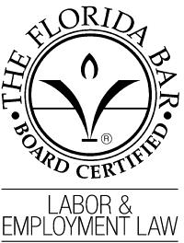
LABOR & EMPLOYMENT CERTIFICATION EXAMINATION SPECIFICATIONS

- Purpose of Examination

The Labor & Employment Certification Examination consists of a combination of essay, short answer, and multiple choice questions. It is intended to test whether an applicant possesses the knowledge, skills, abilities, ethics, and judgments that are common to specialists in Labor & Employment law and is also intended to be a valid and reliable measurement to justify the representation of special competence and professionalism that distinguishes a “Florida Bar Board Certified Lawyer.”

- Examination Content

Topics that may be covered on the Labor & Employment examination include:

  - Traditional Labor (Approximately 25%)
    - FLSA
    - Public Sector Collective Bargaining/Career Service
    - NLRA

  - Equal Employment Opportunity (Approximately 25%)
    - Title VII/FCRA
    - ADA
    - ADEA (and related statutes)
    - GINA

  - Hybrid Labor and Employment (Approximately 25%)
    - ERISA, COBRA, ACA, HIPAA
    - FMLA
    - OSHA
    - USERRA

  - Miscellaneous Statutes/Individual Rights (Approximately 25%)
4.1. Reconstruction Era Civil Rights Statutes (1981, 1983, 1985)
  - WARN
  - Drug Testing
  - Employment Torts
  - Equal Pay Act
  - Domestic Violence Leave (Fla. Stat. § 741.313)

  - Preservation and Protection of the Right to Keep and Bear Arms in Motor Vehicle Act of 2008 (Fla. Stat. § 790.251)
  - Federal and state whistleblower protection laws (Sarbanes-Oxley, 18 U.S.C. § 1514A; Fla. Stat. §§ 112.3187, 448.101-105)
  - Florida’s prohibition on Workers’ Compensation retaliation
  - Fair Credit Reporting Act
  - Non-compete agreements
  - Employee Polygraph Protection Act
  - Florida Statutes §§ 448.07 and 725.07

NOTE: The examination will include ethical issues arising in the practice of labor and employment law.

Labor and Employment Law Section Hall of Fame
Nomination Form
Eligibility Guidelines for Nominating a Candidate: Hall of Fame recognition is a posthumous honor, granted only after death. Ordinarily, individuals nominated will have had significant involvement in both the Section and the active practice of labor and employment law in Florida for a substantial portion of his or her career. An individual who had a clear affinity with or connection to the Section but who was not a member may be considered if, on the whole, the individual is otherwise recognized as having had a profound and positive impact on the profession and the field of labor and employment law. Send form to: Angie Froelich, Section Administrator, The Florida Bar, 651 East Jefferson St., Tallahassee, FL 32399-2300.

Name:

Margaret L. "Margie" Cooper

About the Nominee (please print)

Year Nominee Passed Away: 2019

Was nominee an attorney?
❑
✔ Yes No Was nominee a Section member?
✔ Yes No

Last Known Employment Affiliation Before Death (i.e., firm name, employer, etc.):
❑
❑
❑
Jones, Foster, Johnston & Stubbs, P.A.

Other Honors, Awards, or Affiliations:

Criteria for Admission
To be selected for the Hall of Fame, a candidate must meet the following criteria:
  - The candidate must have excelled in the field of labor and employment law and/or must have had a profound positive influence on the field during his or her professional career.
  - The candidate’s professional success and significant contributions must be recognized by his or her peers as having reached and remained at the pinnacle of his or her field.
  - Evidence that the articulated criteria have been met may come from detailed information about the candidate’s credentials, achievements, the impact and implications of those accomplishments, public awards and honors, leadership roles within the Section, published articles, speaking engagements, and reported litigation.
A description of the manner in which the nominee met the criteria for inclusion (i.e., why the nominee should be honored) must be attached to this application.

About the Nominator (please print) NOTE: Nominator must be Section member

Name:
Cathleen Scott

Phone:

Institution/Affiliation:
Scott Wagner Law

Address:
250 South Central Boulevard Suite 104A

City/State/Zip:
Jupiter

Your Relationship to Nominee:
former colleague

Labor Agenda Winter Meeting 2019 Exhibit F1 January 17, 2019
6

Margaret L. COOPER
OBITUARY
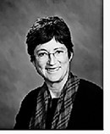
Margaret L. "Margie" Cooper, age 68, of West Palm Beach, FL, a beloved sister, an adored aunt, and a wonderful friend to so many, passed away January 4, 2019. She fought a good fight to the very end, and at the end of her life, as throughout it, she was surrounded by family and friends, all of whom thought the world of her. Margie had a wonderful zest for life; she got more out of life in one year than most people get in ten. We all will miss her greatly. Margie was the daughter of Jack and Barbara Cooper, and is survived by two brothers, David Cooper (wife Margo) and Herb Cooper (wife Joan), one sister, Libby Meiners (husband Joe), eight nieces and nephews (Melissa, Kelly, Theresa, John, Jayna, Matt, Kate, Stephanie), one daughter, Jenny, and a granddaughter, Gianna. Margie was a highly ranked junior tennis player in Florida who won the state high school girls’ singles championship two years in a row. She went on to play Number 1 at Rollins College and then briefly played professionally on the Virginia Slims Tour. She competed in Wimbledon, the French Open and the U.S. Open. She absolutely loved tennis and continued to compete in tournaments throughout her life. In recent years, she was on the board of directors of the International Cup and played in many matches representing the United States in friendly competitions against other countries. She made many, many lifelong friends through the game of tennis, and always was willing to give of herself to help any of her friends. In 2013, she received the prestigious USTA Service Bowl Award at the U.S. Open for her notable contributions to the "Sportsmanship, Fellowship, and Service of Tennis." Margie was a partner and shareholder in the law firm of Jones, Foster, Johnson, and Stubbs, and a recognized expert in commercial and business litigation. She was a Fellow in the American Bar Foundation. She was recognized as one of the top lawyers in South Florida in Labor and Employment Law and Corporate and Business Litigation and was named "West Palm Beach 2014 Employment Lawyer of the Year" in the category of

Litigation and Labor & Employment Law by Best Lawyers in America. Funeral services will be held on Monday, Jan, 21 at 4:00PM at Quattlebaum Funeral home, 5411 Okeechobee Blvd, West Palm. The family kindly requests no flowers. Instead, donations may be made to Rollins College, and designated for Women's Tennis. Send checks to David Cooper at 1807 Barker Dr. Winter Park, FL 32789.

Published in The Palm Beach Post from Jan. 6 to Jan. 20, 2019

Section Bulletin Board

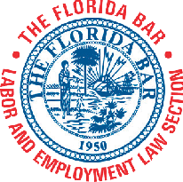19th Labor & Employment Law Annual Update and Certification Review (2882) January 17-18, 2019
Doubletree by Hilton at SeaWorld, Orlando

EC Mtg: January 17, 2019

FLSA Ethical Conundrums: Good Faith Defense Versus Lawyer as Witness and Sanctionable (Mis)Conduct (3113)
AUDIO WEBCAST
February 6, 2019
12:00 noon – 12:50 p.m.

Sexual Harassment Issues in the #MeToo Era: What Has Changed and What Has Stayed the Same (2887)

AUDIO WEBCAST
March 6, 2019
12:00 noon – 12:50 p.m.

Be in the Know: Highlights of Executive Compensation for Employment Agreements (2885) and Tax Considerations in Employment Law (2886)

AUDIO WEBCAST
March 27, 2019
12:00 noon – 1:50 p.m.

ADA Title III Cases: New Tactics and Strategies (3150)

AUDIO WEBCAST
April 3, 2019
12:00 noon – 12:50 p.m.

Advanced Labor Topics 2019 (2888)
April 12-13, 2019
Wyndham Grand Jupiter at Harbourside Place, Jupiter

EC Leadership Mtg: April 13, 2019

Update on Gender Discrimination: The New Gender Equality (2883) AUDIO WEBCAST
June 5, 2019
12:00 noon – 12:50 p.m.

Annual Meeting
June 27, 2019
Boca Raton Resort & Club

EC Mtg: June 27, 2019

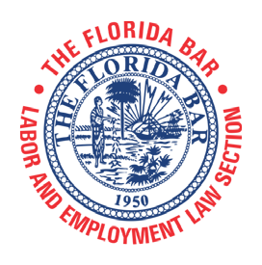
The Florida Bar Continuing Legal Education Committee and the Labor and Employment Law Section present
19th Labor and Employment Law
Annual Update and Certification Review
Course No. 2882R • Advanced Level • Live Presentation

THURSDAY, JANUARY 17, 2019
7:45 a.m. – 8:10 a.m.
Late Registration
8:10 a.m. – 8:20 a.m.
Opening Remarks
Marlene Quintana, Program Co-Chair, GrayRobinson, P.A., Miami Luis A. “Tony” Cabassa, Program Co-Chair, Wenzel Fenton
Cabassa, P.A., Tampa
8:20 a.m. – 8:50 a.m.
ERISA
Sherril Colombo, Littler Mendelson, P.C., Miami
8:50 a.m. – 9:30 a.m.
Whistleblower Statutes/Workers’ Compensation Retaliation
Karen Buesing, Akerman LLP, Tampa
9:30 a.m. – 9:40 a.m. Break
9:40 a.m. – 10:50 a.m.
Family and Medical Leave Act
Jennifer Fowler-Hermes, Williams Parker Harrison Dietz & Getzen, Sarasota
10:50 a.m. – 11:40 p.m.
Common Law Employment Claims
Brian Lerner, Kim Vaughan Lerner, LLP, Fort Lauderdale
11:40 p.m. – 12:40 p.m.
Lunch (included in registration fee)
12:40 p.m. – 1:10 p.m.
USERRA
Kathryn S. Piscitelli, Orlando
1:10 p.m. – 1:35 p.m.
Unemployment Appeals
Amanda L. Neff, Florida Reemployment Assistance Appeals Commission, Tallahassee
1:35 p.m. – 2:40 p.m.
Public Employee Relations Act
Stephanie M. Marchman, GrayRobinson, P.A., Gainesville
2:40 p.m. – 2:50 p.m. Break
2:50 p.m. – 3:40 p.m.
Fair Labor Standards Act
Daniel R. Levine, Padula Bennardo Levine LLP, Boca Raton
3:40 p.m. – 4:15 p.m.
ACA
Cathleen Scott, Scott, Wagner & Associates, P.A., Jupiter
4:15 p.m. – 4:45 p.m.
Drug Testing
Nathan J. Paulich, Thompson Sizemore Gonzalez & Hearing, P.A., Tampa
FRIDAY, JANUARY 18, 2019
8:00 a.m. – 8:05 a.m.
Opening Remarks
Marlene Quintana, Program Co-Chair, GrayRobinson, P.A., Miami Luis A. “Tony” Cabassa, Program Co-Chair, Wenzel Fenton
Cabassa, P.A., Tampa
8:05 a.m. – 8:30 a.m.
Constitutional Employment Claims
Jennifer T. Williams, Cozen O’Connor, Miami
8:30 a.m. – 9:20 a.m.
National Labor Relations Act
James M. Craig, Macfarlane Ferguson & McMullen, Tampa
9:20 a.m. – 10:10 a.m.
Worker Adjustment and Retraining Notification Act
Ryan D. Barack, Kwall Barack Nadeau, PLLC, Clearwater
10:10 a.m. – 10:15 a.m. Break
10:15 a.m. – 12:05 p.m.
EEO – Substantive
Kevin D. Johnson, Johnson Jackson, LLC, Tampa Erin G. Jackson, Johnson Jackson, LLC, Tampa
12:05 p.m. – 1:35 p.m.
Lunch (included in registration fee)
Cathleen Bremmer, Carlton Fields Jorden Burt, P.A., Tampa
1:35 p.m. – 2:25 p.m.
EEO – Procedural
Diane P. Perez, Diane Perez, P.A., Coral Gables
2:25 p.m. – 3:25 p.m.
Statutory and Common Law Protection of Business Interests
M. Sean Moyles, Langston Hess Hussey Greenhill & Moyles, Clearwater
3:25 p.m. – 3:30 p.m. Break
3:30 p.m. – 4:00 p.m.
OSHA
Phillip B. Russell, Ogletree, Deakins, Nash, Smoak & Stewart, Tampa
Dee Anna Hayes, Ogletree, Deakins, Nash, Smoak & Stewart, Tampa
4:00 p.m. – 4:30 p.m.
Workplace Privacy/FCRA
Gregory A. Hearing, Thompson Sizemore Gonzalez & Hearing P.A., Tampa

CLE CREDITS

CLER PROGRAM
General: 16.5 hours
CERTIFICATION PROGRAM
Labor and Employment Law: 16.5 hours

Labor Agenda Winter Meeting 2019 Exhibit H January 17, 2019

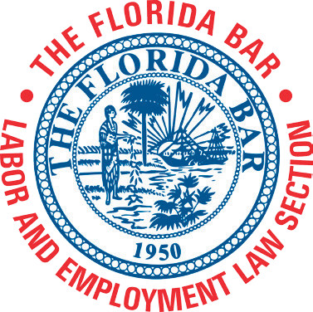2018 -2019 Audio Webcast Series (2957)

The Florida Bar
Labor and Employment Law Section

November 7, 2018
12:00 noon – 12:50 p.m.

The Intersection of Medical Marijuana and Employment Law (2884)
Learn about the new regulations and how employers should respond to employees with prescriptions for marijuana. The do's and don'ts for companies will be discussed, as well as the rights employees who take medical marijuana have under federal and state laws.
Richard Blau, Gray Robinson, Tampa, FL Marlene Quintana, Gray Robinson, Miami, FL

February 6, 2019
12:00 noon – 12:50 p.m.

FLSA Ethical Conundrums: Good Faith Defense Versus Lawyer as Witness and Sanctionable (Mis)Conduct (3113)
Learn how to tell ethical issues from zealous advocacy and how to curtail unethical behavior.
Leslie W. Langbein, Langbein & Langbein, P.A., Miami Lakes, FL

March 6, 2019
12:00 noon – 12:50 p.m.

Sexual Harassment Issues in the #MeToo Era:
What Has Changed and What Has Stayed the Same (2887)
This webcast will cover best practices for preventing and addressing harassment; policies; the law regarding sexual favoritism (Can the boss promote his or her partner over more qualified candidates?); monitoring digital platforms for harassment; the interplay between harassment and common law torts, such as negligent hiring/supervision/retention; and how the changes in the tax code and NDAs have affected these claims and how to deal with claims.
Zascha Blanco Abbott, Liebler, Gonzalez & Portuondo, Miami
March 27, 2019
12:00 noon – 1:50 p.m.

Be in the Know: Highlights of Executive Compensation for Employment Agreements (2885) and
Tax Considerations in Employment Law (2996) This presentation will cover appropriate contract provisions to consider in drafting executive employment agreements; executive clawbacks; the new Section 83(i); and the impact of tax reform on designing competitive compensation packages, and advise employment lawyers what they need to know about taxation
issues in drafting employment, contracts, using independent contractors, advising their clients about employment-related matters.
Thomas Hickey, Gunster, West Palm Beach, FL

April 3, 2019
12:00 noon – 12:50 p.m.

ADA Title III Cases: New Tactics and Strategies (3150)
Hear about current developments in the Title III arena and learn
new approaches to old problems.
Cathleen A. Scott, Scott Wagner & Associates, P.A., Jupiter Allison B. Duffie, Scott Wagner & Associates, P.A., Jupiter

June 5, 2019
12:00 noon – 12:50 p.m.

Update on Gender Discrimination: The New Gender Equality (2883)
The discussion will include legal issues for LGBTQ+ individuals; rights and changes in how courts view discrimination claims and the Tale of the Baker – the new balancing test; Florida’s Competitive Workforce Act; and the status of local protections around the state.
Lindsey Wagner, Scott Wagner & Associates, P.A., Jupiter, FL and Burbank, CA
Jon Harris Maurer, Equality Florida, Tallahassee

CLER PROGRAM
Max. Credit: 7.0 hours

CLER PROGRAM

CERTIFICATION PROGRAM
Max. Credit: 7.0 hours

General: 7.0 hours for series; 1.0 hour per program Ethics: 1.0 hour for series; 1.0 hour for 3113
Labor and Employment Law: 7.0 hours; 1.0 hour per program Tax Law: 1.0 hour for series: 1.0 hour for 2886

To register, log into The Florida Bar Members Portal at www.member.floridabar.org, click CLE Events/Meetings and scroll to the desired course, OR click on a title above.

Labor Agenda Winter Meeting 2019 Exhibit I January 17, 2019

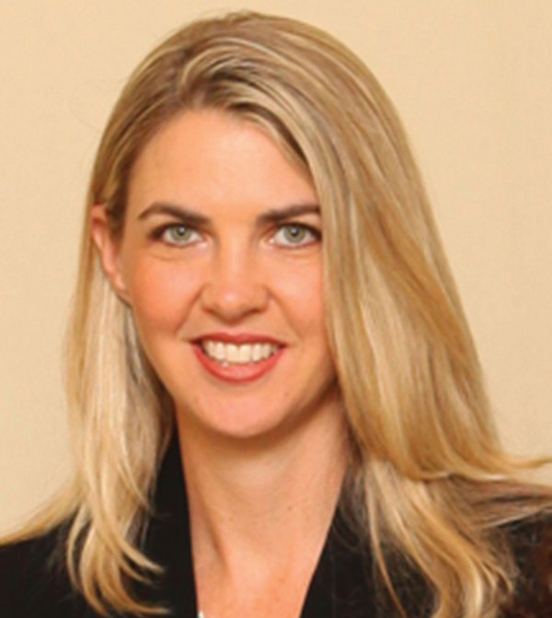

CATHLEEN SCOTT

R_{eception}
in chaiR’s suite

Thursday, January 17, 2019
7:00 p.m. - 8:30 p.m.

Directions to Suite# 21706 from Lobby

- Down the hall, out the sliding glass doors—make a left.
- You will pass the Laguna Restaurant; and on the right-hand side you will see the tower.
- Take the elevator to the 17th floor, and the lounge (connecting to
Cathleen’s room) will be on the right with a double door entrance.

Labor Agenda Exhibit J January 17, 2019

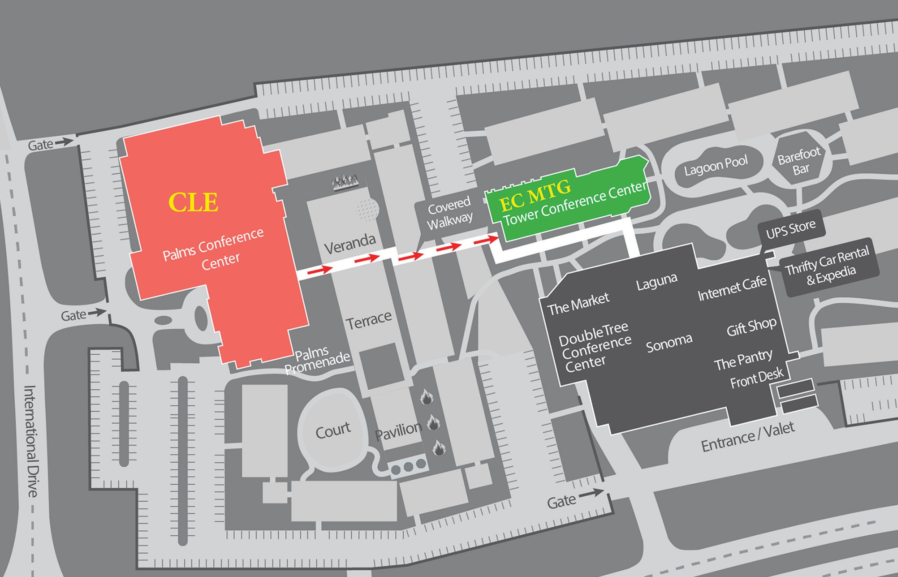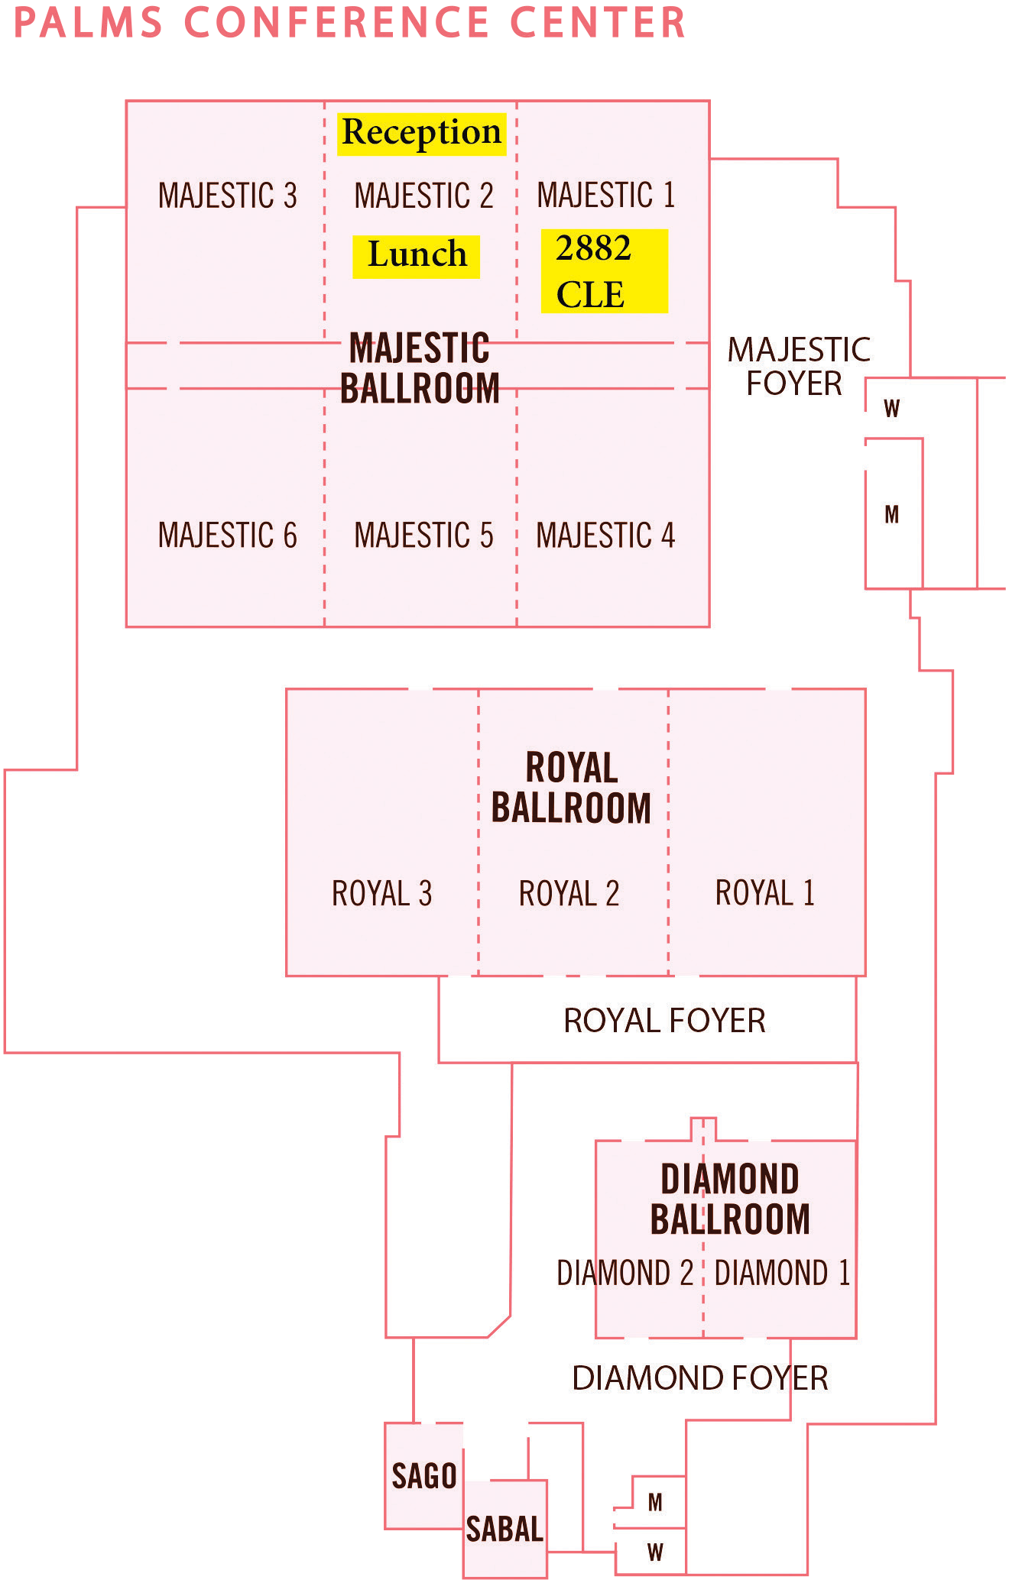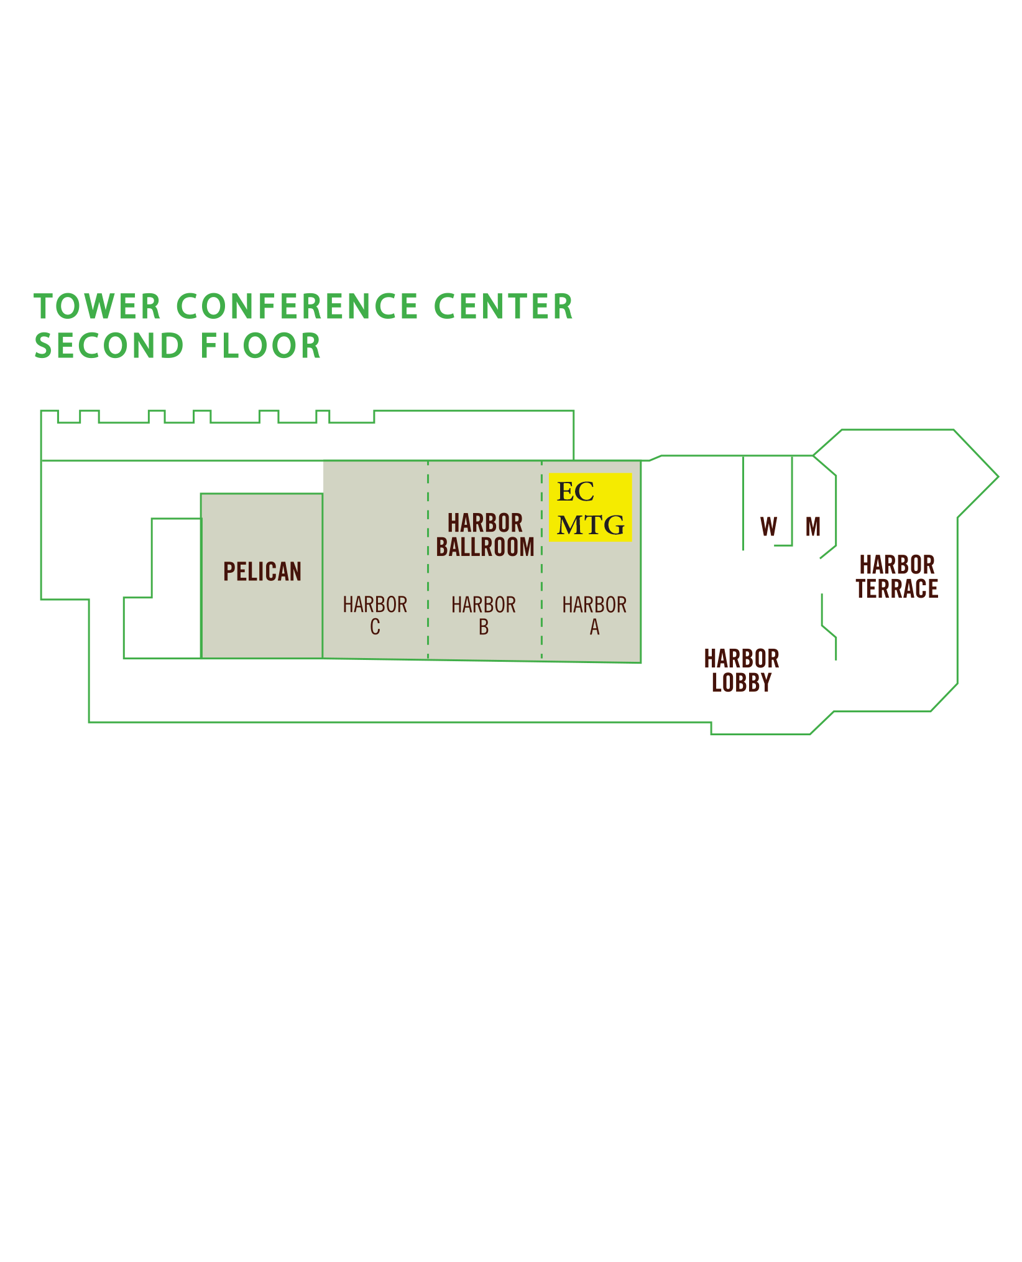Winter Meeting 2019

Labor and eMpLoyMent LaW Section

Labor Agenda Winter Meeting 2019 Exhibit K January 17, 2019

