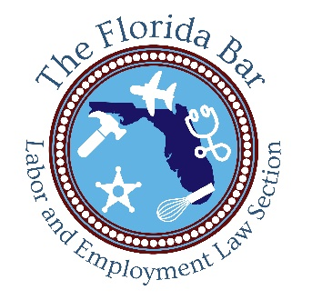
Labor and Employment Law Section
MASTER CALENDAR

October 2019

October 17-18, 2019

3476 45th Annual Public Employment Labor Relations Forum
The Rosen Plaza
9700 International Drive
Orlando, Florida 32819
(407)996-9700
www.rosenplaza.com

November 2019

November 15, 2019

3573 Have You Googled It? Website Accessibility Under Title II and Title III of the ADA
Audio Webcast

December 2019

December 11, 2019

3574 We’re at Impasse. Now What? Best Practices for the Impasse and Special Magistrate Process
Audio Webcast

January 2020

January 8, 2020

3575 Be an Expert in Handling Experts: Best Practices for Expert Designation, Discovery, Direct and Cross-Examination
Audio Webcast

February 2020

February 5, 2020

3576 Flexible Work Arrangements: Legal Implications of a Millennial Must Have
Audio Webcast

February 6-7, 2020

3491 20th Labor and Employment Law Annual Update and Certification Review
The Florida Bar Winter Meeting
Hyatt Regency Orlando
9801 International Drive
Orlando, FL 32819
(407) 284-1234

March 2020

March 5, 2020

Practicing Before State Agencies
University Center Club
403 Stadium Dr Building B
Tallahassee, FL 32306
(850) 644-8528

March 11, 2020

3577 Hot Topics in Public Sector Bargaining
Audio Webcast

April 2020

April 3-4, 2020

3150 Advanced Labor Topics 2020
Washington, D.C.

April 8, 2020

3578 New Rules of Reason or Reasons to Rue? NLRB Decisions Changing the Landscape of the Union and Non-Union Workplace
Audio Webcast

May 2020

May 6, 2020

3572 What Employers and Employees Need to Know About the GDPR, CCPA, and Emerging Privacy Laws
Audio Webcast

June 2020

June 18, 2020

Labor and Employment Law Executive Council Meeting
Hilton Orlando Bonnet Creek
14100 Bonnet Creek Resort Lane
Orlando, FL 32821
(407) 597-3600

August 2020

Trial Skills Conference
Tampa

