MARGARET L. “MARGIE” COOPER (1950 - 2019)

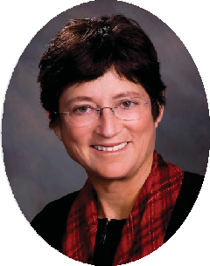
Board Certified by The Florida Bar in both Civil Trial Law and Business Litigation, Margaret L. “Margie” Cooper practiced law at Jones Foster P.A. for forty- two years. She was a Fellow in the American Bar Foundation, a former Chair of The Florida Bar Grievance Committee for the 15th Judicial Circuit, and a former member of The Florida Bar Judicial Nominating Procedures Committee. Consistently a top-rated lawyer in her field, Margie was named “West Palm Beach 2014 Employment Lawyer of the Year” by Best Lawyers. Margie graduated with a B.A. from Rollins College and obtained her J.D. from Mercer University.

