WILLIAM RUSSELL “RUSS” HAMILTON, III (1946 - 2018)

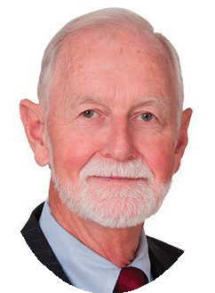
In a career spanning four decades, William Russell “Russ” Hamilton III represented companies large and small in all types of labor and employment law matters. Russ was routinely top-rated in his field, including by The American Lawyer as part of the “Litigation Department of the Year—Labor and Employment Law Winner 2006.” He also helped create the Academy of Florida Management Attorneys (AFMA) and served as its president. Russ was a graduate of Stetson University and of the Walter F. George School of Law at Mercer University. He finished his career as Of Counsel to FordHarrison LLP.

