WILLIAM RAYMOND “BILL” RADFORD (1936 - 2018)

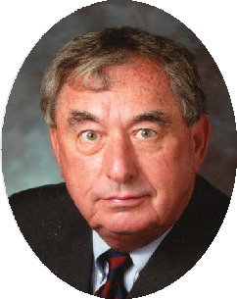
William Raymond “Bill” Radford was a graduate of Wittenberg University and the University of Michigan Law School. Board Certified by The Florida Bar in Labor and Employment Law, Bill represented employers for more than forty years in both the public and private sectors. He was elected a Fellow in the College of Labor and Employment Lawyers and was named “Lawyer of the Year” for Labor and Employment in 2014 by Best Lawyers. Throughout his career, practicing with Morgan Lewis, FordHarrison, and Ogletree Deakins, Bill was involved in cases that broke new legal ground.

