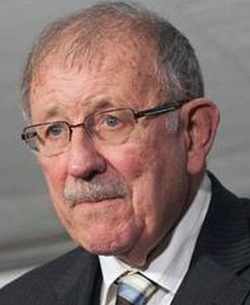
Photo from jimmyryce.org

Donald T. Ryce, Jr. Inducted into Section Hall of Fame

Donald T. Ryce, Jr. (1943–2020) was inducted into the L&E Section Hall of Fame on October 23, 2020. He practiced in the areas of labor and employment law, commercial litigation, and appellate law from 1970 to 2010. He retired from his law practice in 2010 but remained active as a full-time neutral arbitrator. At the time of his death, Don was a partner in the Vero Beach arbitration firm of Law and Arbitration Offices of Donald T. Ryce.
Don received both his B.A. degree and his J.D. degree from the University of Florida. A member of The Florida Bar, Don began his career as a law clerk for a judge on Florida’s Fourth District Court of Appeal and then became a named partner in the law firm of Hogg, Allen, Ryce, Norton & Blue before starting his own law firm in 1989.
Don was on the American Arbitration Association’s National Roster of Labor Arbitrators and on its National and Florida Roster of Employment Arbitrators, and was a member of the AAA’S Commercial Arbitration Panel. He was also on the Roster of Labor Arbitrators for the Federal Mediation and Conciliation Service and was on the permanent panel of Hearing Examiners for Miami-Dade County. Additionally, Don was a public arbitrator and was chair and injunction-qualified for FINRA Dispute Resolution, the largest securities dispute resolution forum in the world. He was also an arbitrator on the employment and general Florida panel for National Arbitration and Mediation, Inc.
Don wrote numerous articles and was a frequent lecturer for various professional groups on a variety of legal and arbitration issues. He lectured on behalf of the U.S. Department of Justice to a variety of audiences, including federal, state, and local law enforcement.
He was listed in Who’s Who in America, Who's Who in American Law, and the Bar Register of Preeminent Lawyers. He was selected for inclusion in the 2008-2010 editions of Marquis Who's Who in America and in the 2008-2010 Florida Super Lawyers.
Until his semi-retirement from active representation of clients in 2010, Don was a member of The Florida Bar Labor and Employment Law Section Executive Council and chair of the Section’s Voluntary/Local Bar Subcommittee.
Don also had a life outside labor and employment law, having become an advocate for families of missing children after his youngest son, Jimmy Ryce, was abducted and murdered on September 11, 1995. From that moment on, Don and his family devoted their efforts to helping others, founding the Jimmy Ryce Center for Victims of Predatory Abduction. One of the Center’s main goals is to provide bloodhounds, free of charge, to law enforcement agencies. As of the time of Don’s death, the Jimmy Ryce Center had donated over 600 bloodhounds.

Don also fought tirelessly to change legislation to protect children from predators and attended two bill-signing ceremonies at the White House, one with President George W. Bush and the other with President Bill Clinton. Don was Chairperson Emeritus of the Florida Department of Law Enforcement’s Advisory Board and a Director of The Jimmy Ryce Center. He was also a member of Team Hope, a group sponsored by the Office of Juvenile Justice and Delinquency Prevention and the National Center for Missing and Exploited Children, which advises victim parents.

Biographical information in part from FloridaArbitrator.net.

